Title: Chapter 2 Name: Kamas Peterson

Health is when both your body and your mind are taken care of. Having good relationships with both friends and family that help and support you through your everyday life. Health is also taking care of your spiritual health as well so going to church, praying, reading scriptures, etc. When it comes to me, I would say on a scale of one to full that I am ½. I would say that if anything that I could work on is my spiritual side. Especially on how to study my scriptures better. I feel that when reading scriptures I seem to glaze over what I am suppose to learn from the stories. Making it so that I can not grow and expand.

Work is when you are assigned to do something that you get paid to do for a set amount of time each day. Work can also be a service that you do for free and do willingly for some that needs help. Work can also be for family like the yard work, cleaning the house, or helping someone move. Over the years I have done work for family, service projects for a school club, and for two summers worked for my school district. Work has been important to me because from a young age both my parents have taught me how work is important and that we need to get a job. On a sore from 0 to full I would say that my work ethic is full.

Play is a range from physical activities to board games. Physical games could be sports such as track, football, basketball, rugby, soccer, etc. When it comes to sports, I have done swim team from nine years old till the age of thirteen, next I did one year of cross country and seven years in total including middle and high school of track. Sports is another thing that was stressed in my household that was important to do to not only experience but to stay healthy. Again, board games is another form of play and can range from games like monopoly, ticket to ride, checkers, chess, etc. As a family I would say that we all enjoy playing games together and has become more fun over time doing it with more than family especially playing with friends. For playing I would say that from zero to full I would say that I am full.

Love is knowing that you have lots of people around you that care for you and support you with anything that you do. Not only having others love you but that you also love yourself for who you are and have confidence in your abilities. When it comes to family and people around me that support me, I would say that I have lots of people that have supported me and loved and nurtured me over the years. Over the years it has taken me a long time to figure out what I love about myself and to find confidence, but I would say that I am still working on it. Finally, from a scale of zero to full I would say that love is full.

Work Reflection

Working is important so that your can have a purpose in life and so that you are constantly learning and growing. Working helps us to be able to support ourselves, others, and our needs. Work is a physical action that you do every day, week, and year for a set amount of money and time. Depending on the job you have certain benefits that come with it. For some people work gives them a reason to live to survive. For others work is another means to an end, that they are just waiting for retirement so that they can do whatever they want. Therefore, for money is what some people work for rather than working for enjoyment.

Money is a huge part of why people work so that they can enjoy the things they want and experience what they want. Rather than finding a job that they will enjoy they find a job that will give them lots of money. For me I would rather find a job that I will enjoy and that will support me for the rest of my life. Finding a job that you enjoy for the rest of your life will make it so you’re not constantly wanting something more. To get the job that you want you need to gain experience which also means you need to get a job first so that you get to were you want to. Not only that you need to be willing to continue to learn and grow so that you become more valuable

Life view Reflection

As a member of the Church of Jesus Christ of Latter-Day Saints I would say that the purpose of this life is to be tested. The reason why we are here so that we can become more like our Heavenly Father and return to heaven. As a member the church I believe that we are all brothers and sisters. Which I believe because of the belief that we are all Heavenly Fathers children. Another core belief is that we should all get married and that it should be between a man and woman. Therefore, the next biggest relationships that we all have is our families.

One the most important relationships is family. As an individual I have found that family is the most important relationship that anyone could have. The reason for that belief comes from the fact that they have given me so much support, protection, safety, advise and they have provided for me. When it comes to who comes first in my life it is my family then my country and next would be the rest of the world. The reason why family is so important is because of the biggest instincts that I think that we all have which is to protect our families. Furthermore, to protect our families our parents teach us what is good and what is evil in this world.

As people we all have a sense of what is good and what is evil in this world. But as the world has progressed the view of what is good and what is evil has changed. As a religious person I try to follow the ten commandments to help me decide what is good and evil. For me good is when someone is following the laws of both where they live and Heavenly father. Evil is when someone is breaking the laws, disrespecting themselves, and others. For me I believe that there is a God, and I would say that he impacts my actions, thoughts, and my conduct. Through Heavenly Father I would say that he has made me feel safe, confident, strong, etc. As said previously that we are sent here to be tested and there is certain thing that play a part in that. Which includes joy, sorrow, justice, injustice, love, peace and strife these all are things that I believe our Heavenly Father wants us to experience. What I believe is that the role that they play is to teach and strengthen us and our lives.

Compare and Contrast

Both work and life connect in part because in order to survive in life we need to work. Partly because in the world today work has become more important than religion. But in order to gain a job you need to have knowledge of a certain subject. One of the biggest things is that we as a member of the church of Jesus Christ of Latter-Day Saints we are asked to gain knowledge, for that is all that we can bring with us when we die. So, in that aspect life and work connect because on both side they desire us as people to gain knowledge.

As the world has evolved religion has become less and less important. Not only has religion faded but the importance of family become less of a priority to people. With being a member of the church, it has taught me that both work, religion, and family all need to be made important in our lives. Often when life becomes desperate the value of work becomes higher and more important than spiritual well-being. Often without having faith it off balance our work lives.

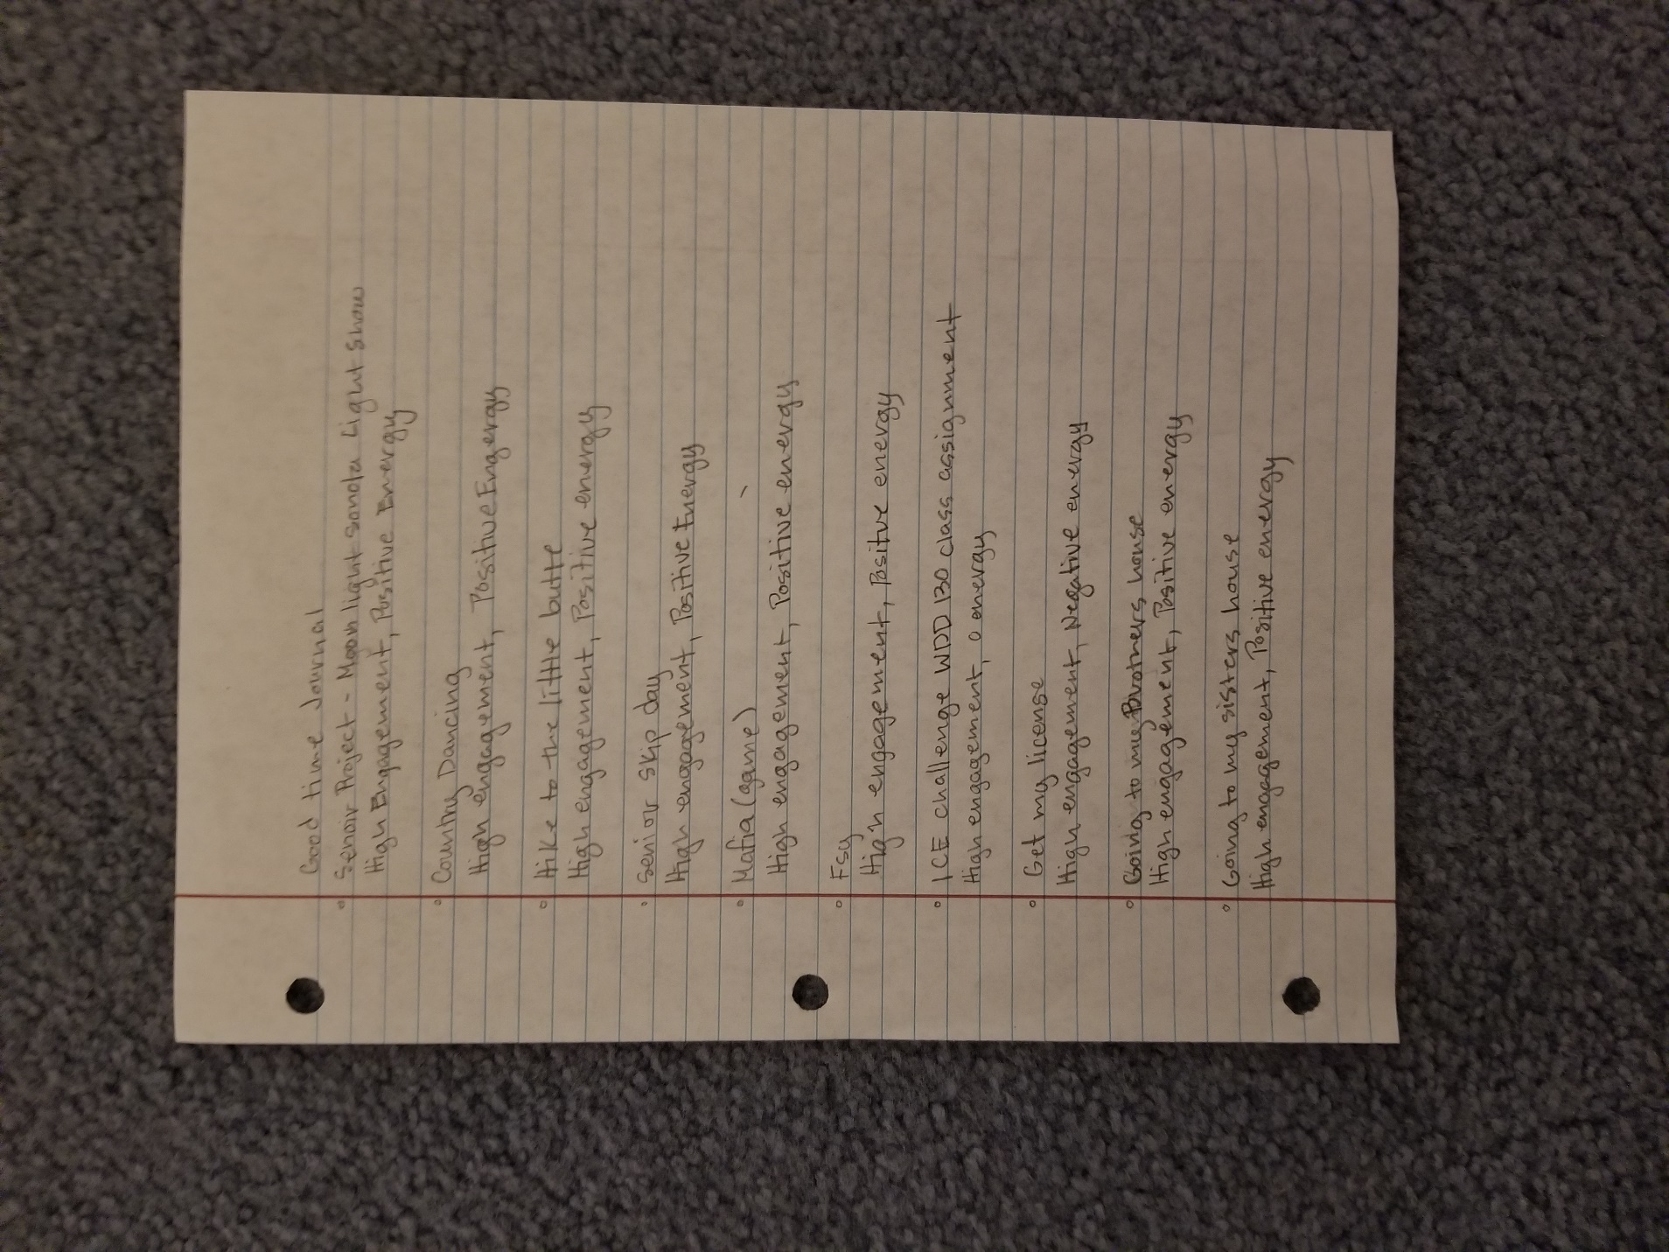

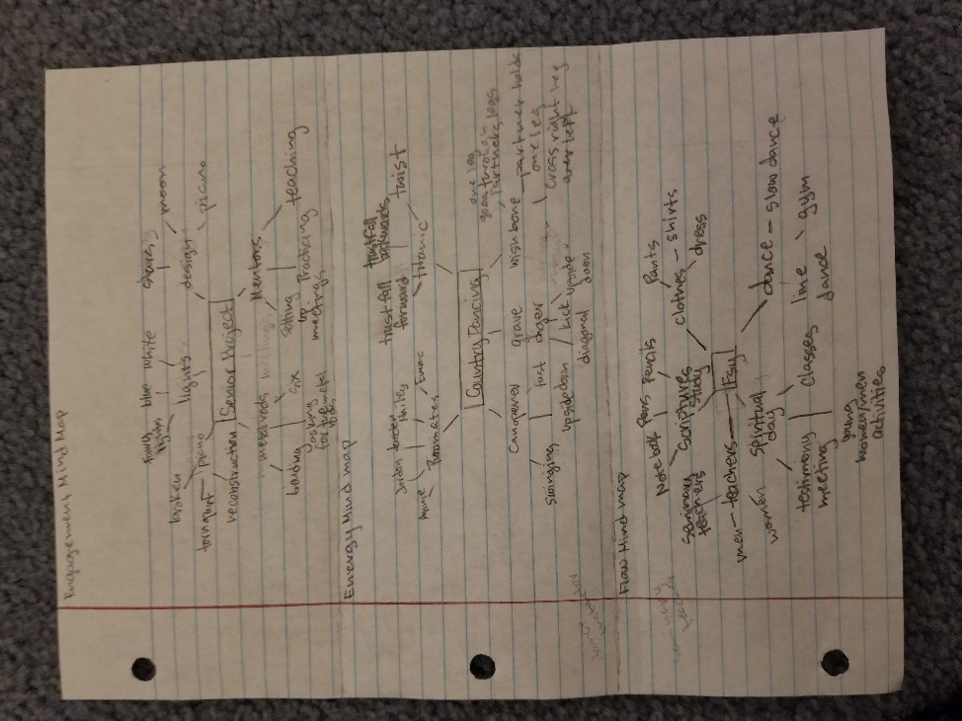

Mind Maps

1. A Lighting Coordinators job is to make certain colors show up a designated time during a show. Another part of their job is to make sure that all the cables are working. Not only that but to make sure that all the equipment is working the right way.
2. A Dance Instructor trains students to dance, and to learn the right form that they need to make while dancing. Another part is that the instructor teaches them how they need to act while dancing. Lastly, they need teach the students how to be creative so that they can learn how to make their own dance.
3. A Seminary Teacher helps students to understand scriptures and the importance of what they are saying. They show them the deeper meaning of certain verses and help them to understand what the prophets in the scriptures wanted to get across.

Odyssey Plan

1. Number one goal to success:

* Resources: 100%
* I Like It: Medium warm
* Confidence: ½ full
* Coherence: 100%
* Will I enjoy the job that I get from this degree 25 years from now?

1. Second Chance

* Resources: 100%
* I Like It: Medium warm
* Confidence: ½ full
* Coherence: 100%
* Will this benefit me more in the long run?

1. Nothing Matters

* Resources: 25%
* I Like It: Hot
* Confidence: Full
* Coherence: 35%
* What do I do with this kind of degree?